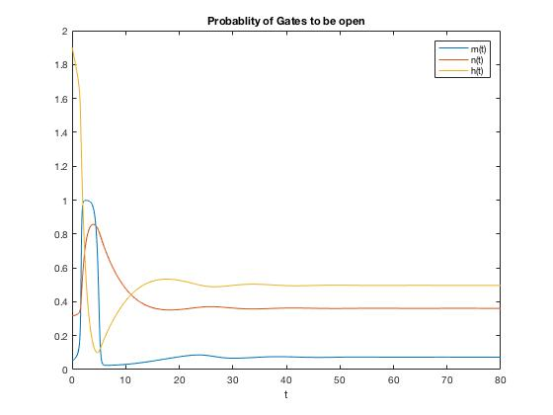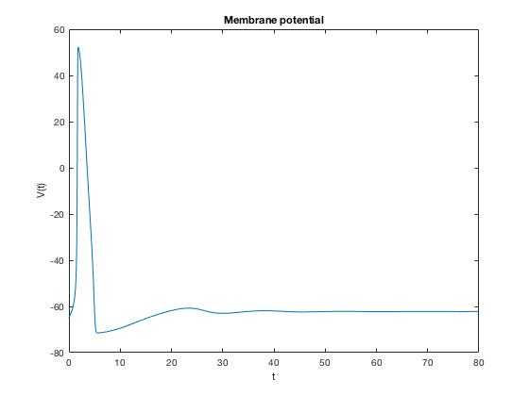

For I=2

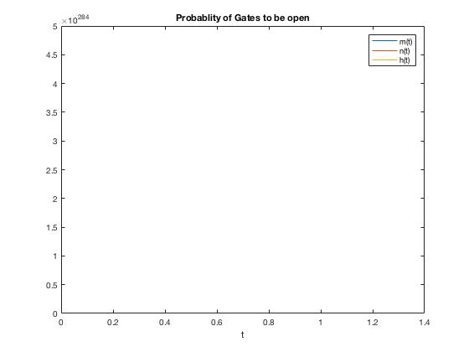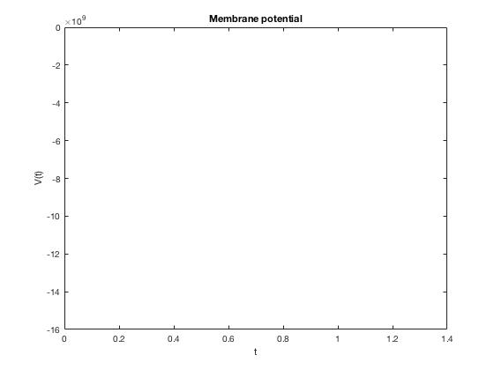

For I=6

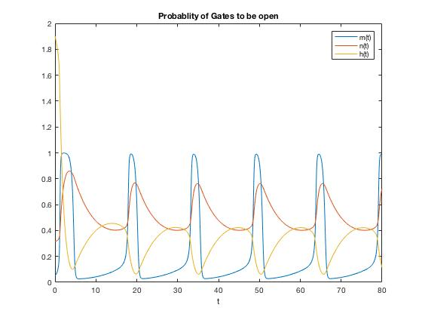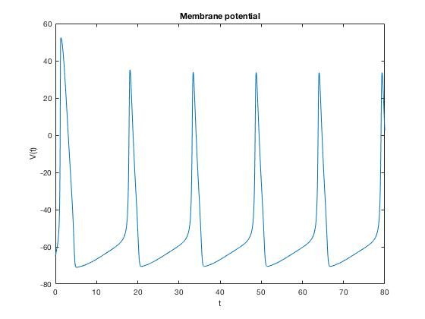

For I=8

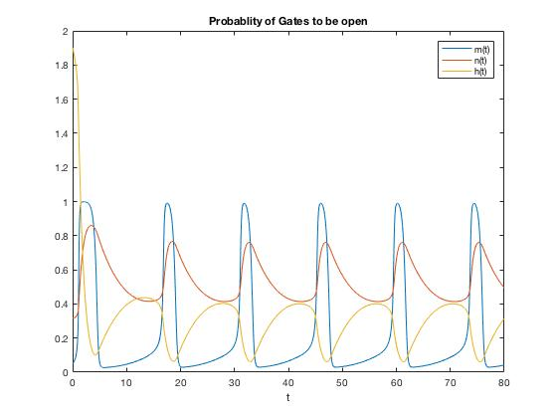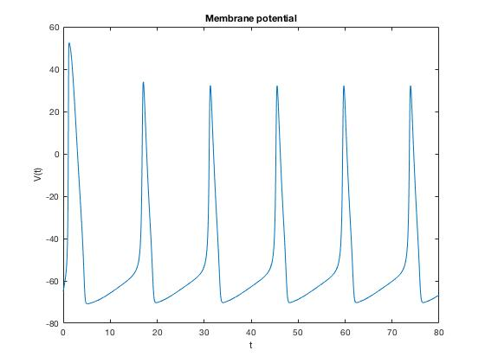

For I=10

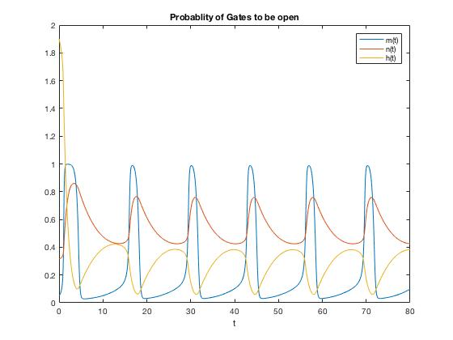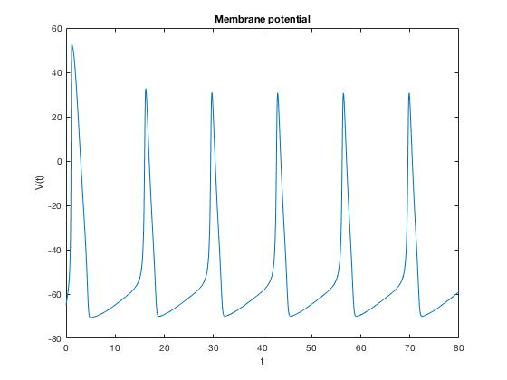

For I=12

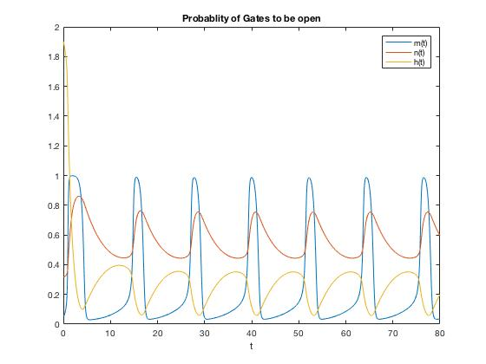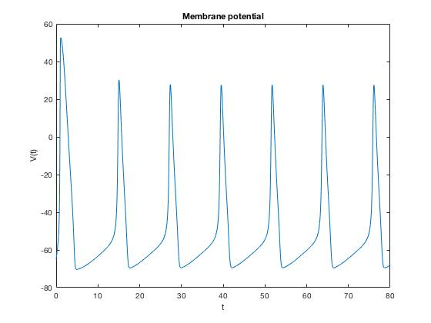

For I =16

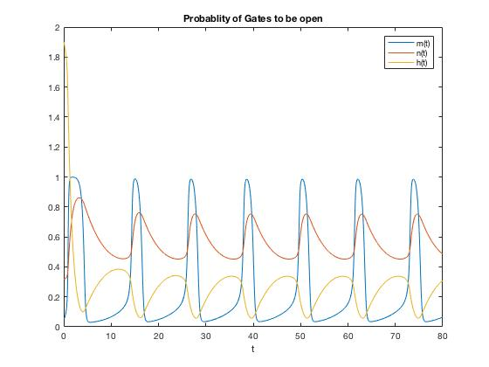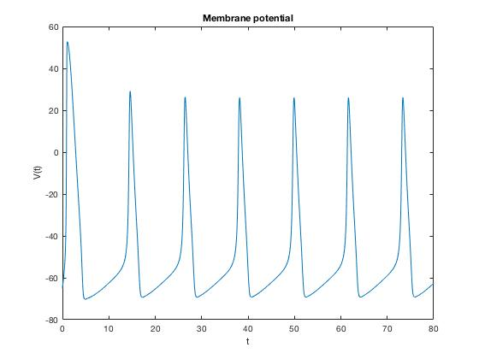

For I=18

I. It spikes for current more that or equal to 8

II. Initially mgates open because of small Tau and H gates are not able to catch up in closing because of large Tau as A result Na+ inflows causing a huge increase in V and thus action potential, Soon H gates close and N gates open so K+ flows outside and the net current is outside. Thus decreasing the Voltage, The Potential going to value lesser than the rest value is explained in written assignment.

III. Duration of spike is 2-3 ms whereas it takes 7-8 ms to get back to resting value after the spike

Iv. yes spikes are periodic because the current is steady

v. Frequency increases as Current increase. This is true because dV/dT is directly proportional to I ext

vi. No the peak of the spikes do not vary from the external current as the spike is because of the action of h,m and n gates , which are voltage controlled.